BIG DATA PROJECT REPORT

Mariam Ibrahim Ali Mahmoud

Shoubra Faculty of engineering

Banha university

Submitted to; Dr. Eng. Ahmed Baiomy

## B.N:890

## github link; https://github.com/mariamibrahimali/ece001

# Application brief

Big data represents one of the most important analytics in our times; because **Big data** analytics helps organizations harness their **data** and use it to identify new opportunities. That, in turn, leads to smarter business moves, more efficient operations, higher profits and happier customers.

## summary

* Big Data definition: Big Data is defined as data that is huge in size. Big data is a term used to describe a collection of data that is huge in size and yet growing exponentially with time.
* Big Data analytics examples includes stock exchanges, social media sites, jet engines, etc.
* Big Data could be 1) Structured, 2) Unstructured, 3) Semi-structured
* Volume, Variety, Velocity, and Variability are few Big Data characteristics
* Improved customer service, better operational efficiency, Better Decision Making are few advantages of Big data

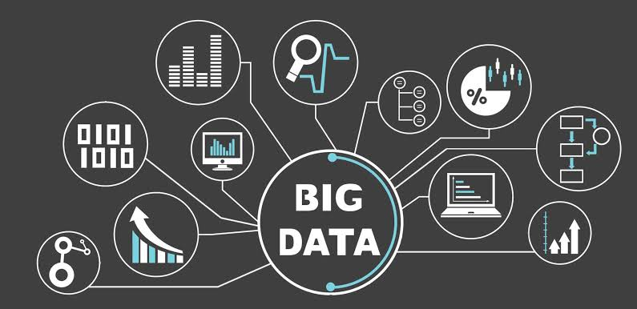

# Screen-shots

# 

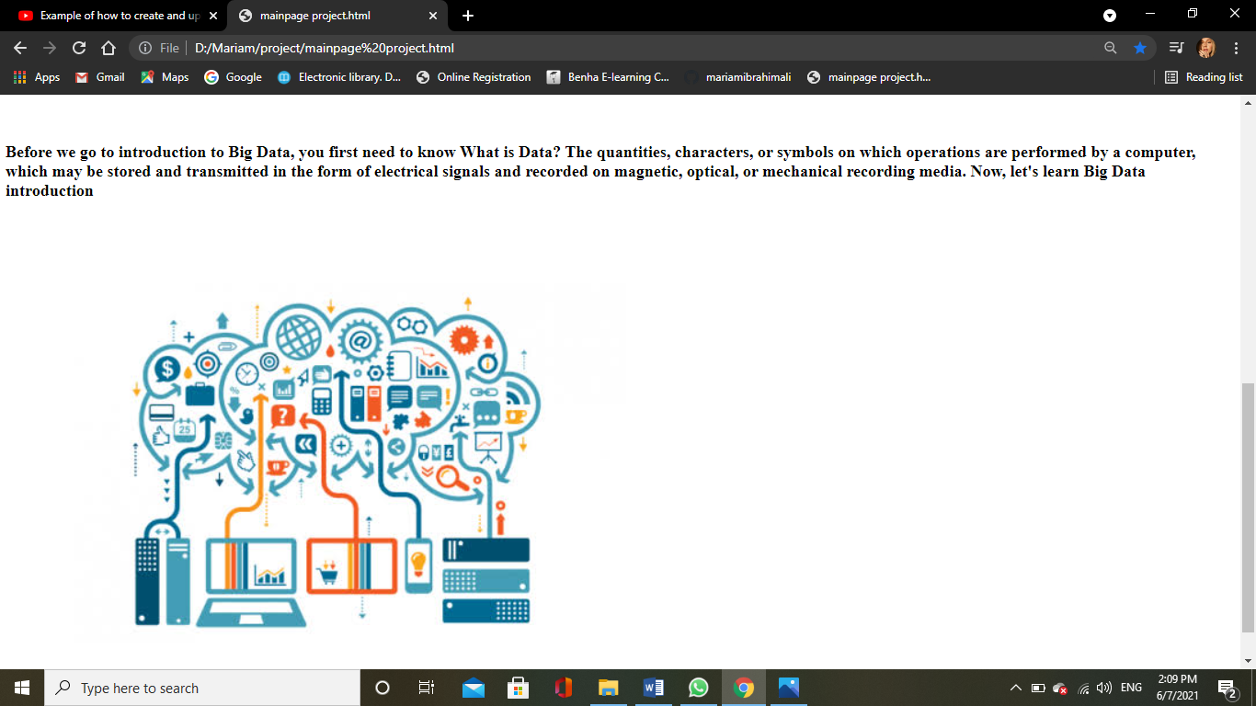

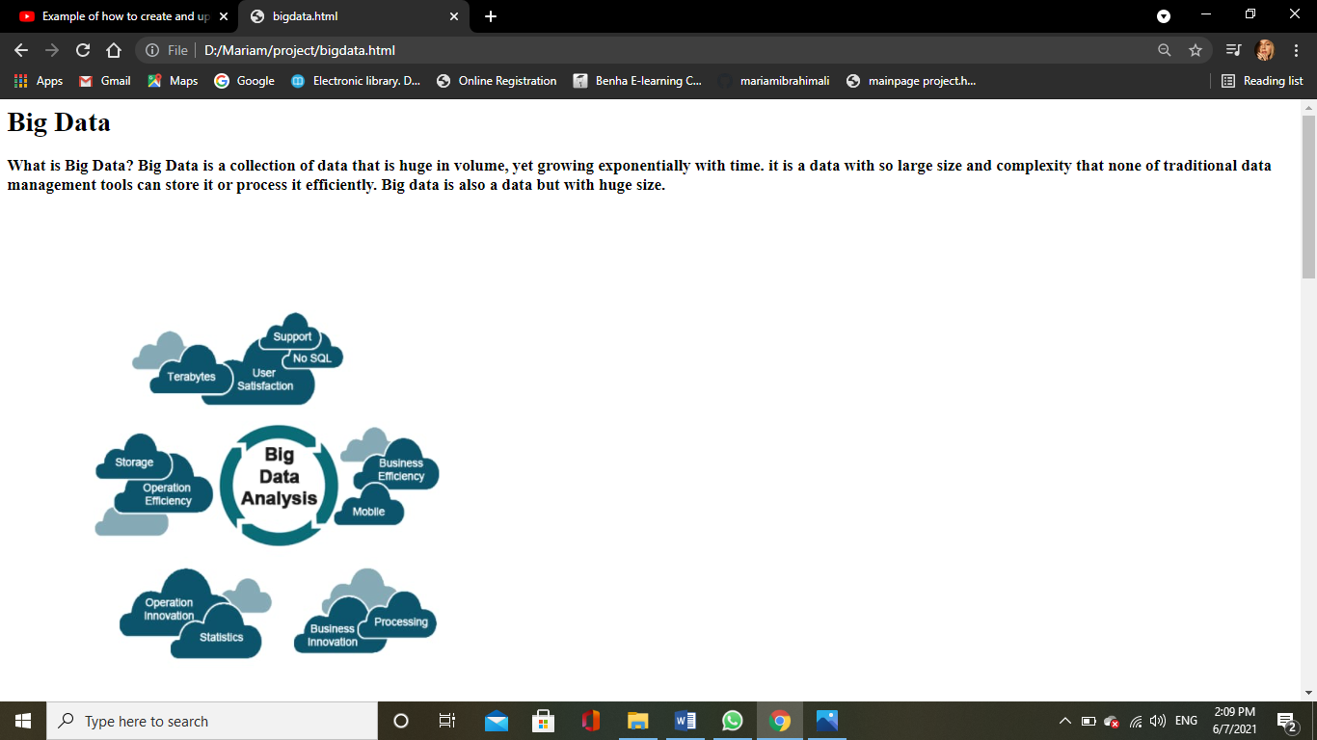

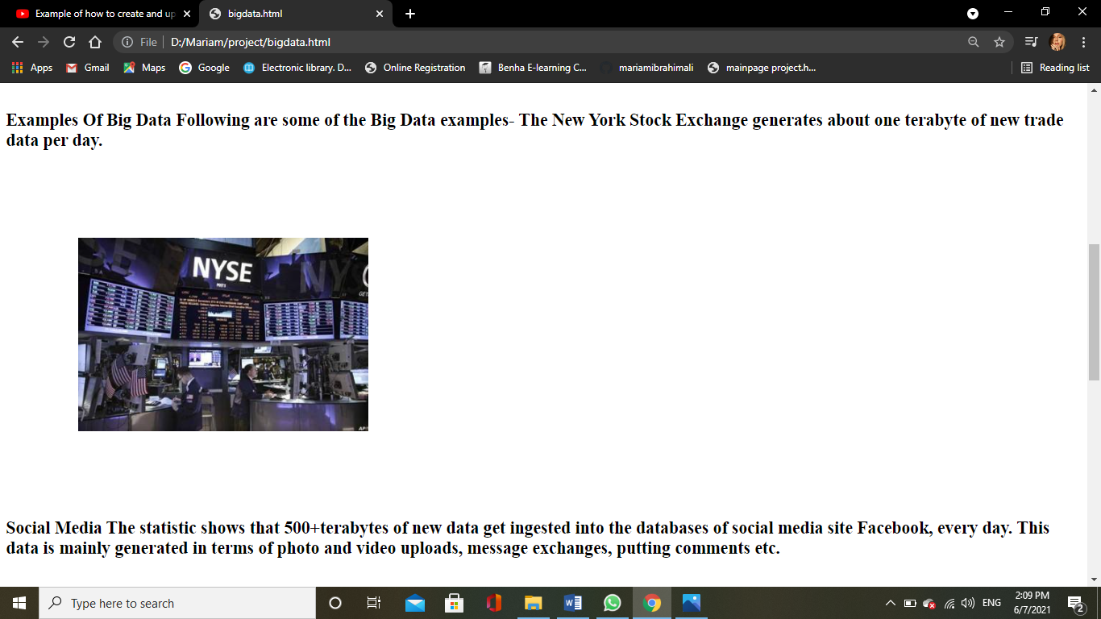

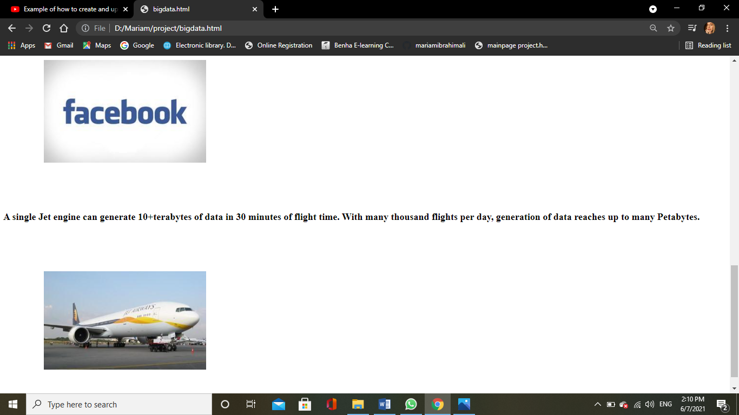

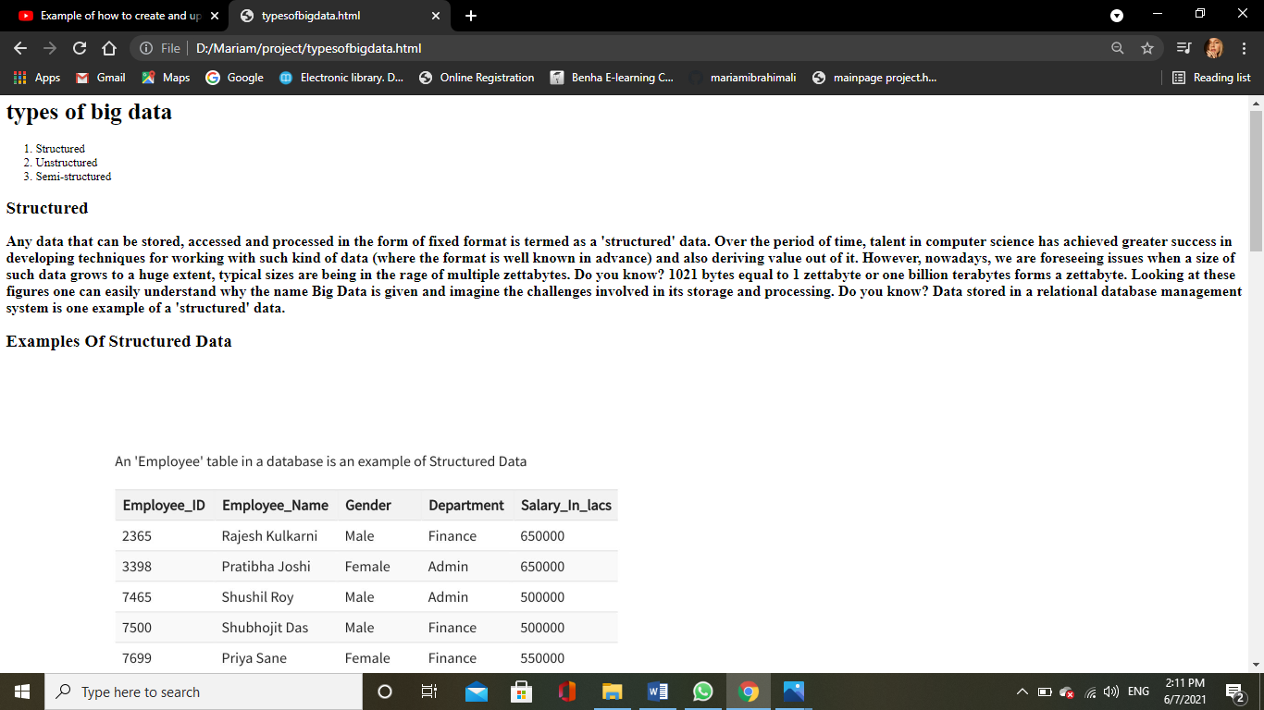

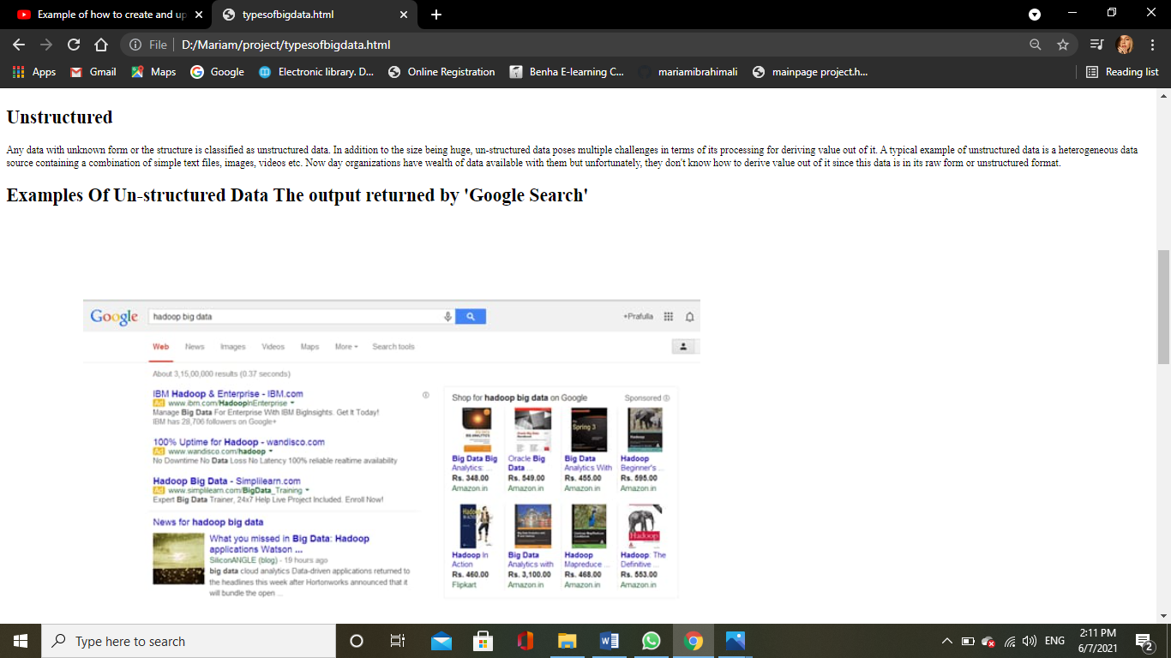

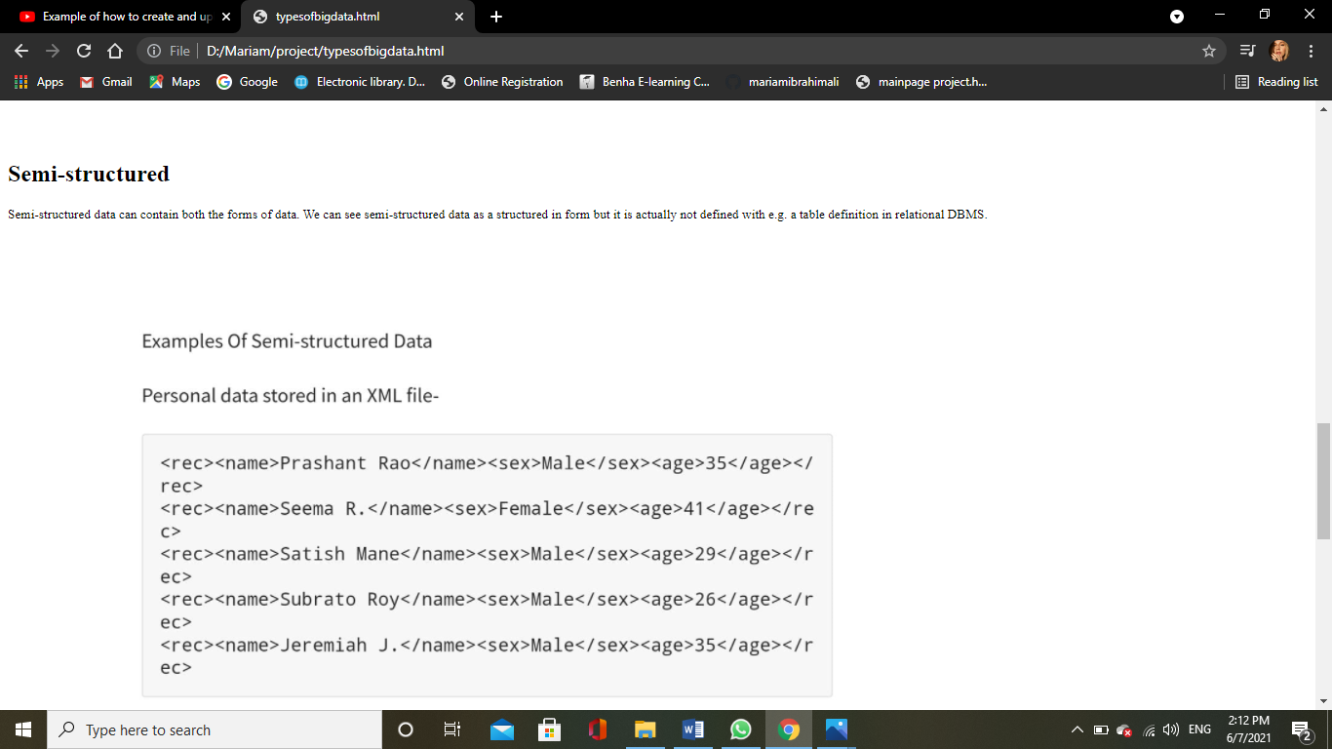

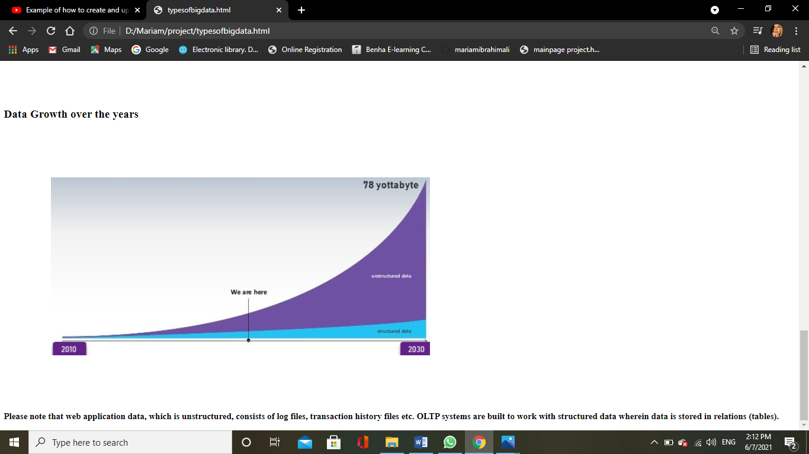

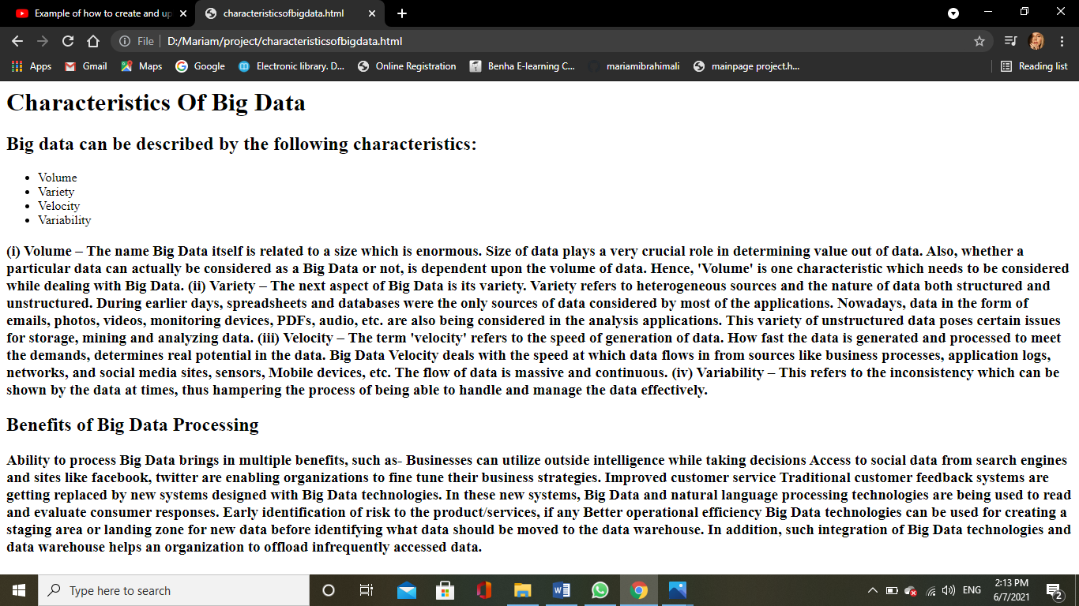

# Source code

Main page code

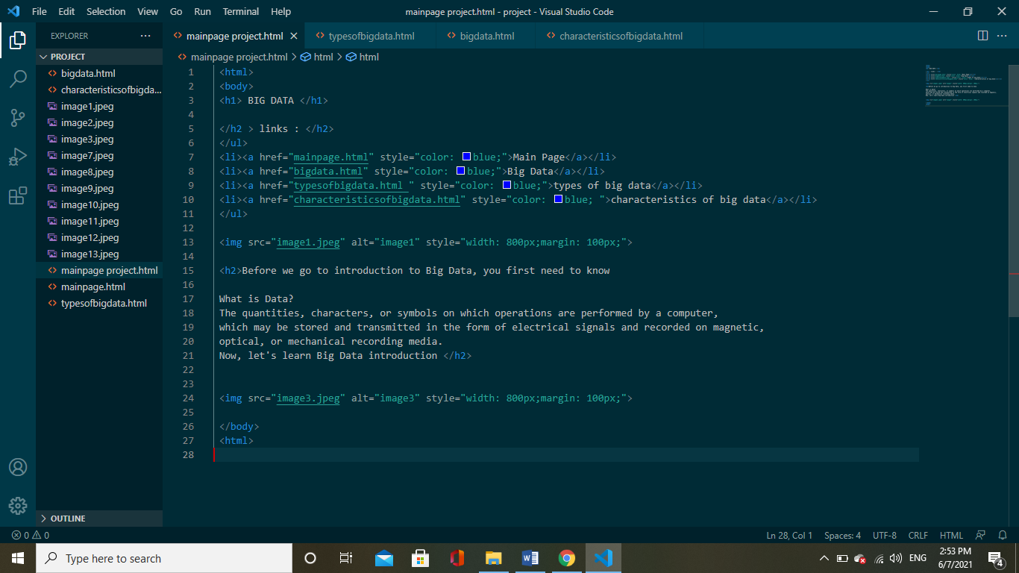

## big data code

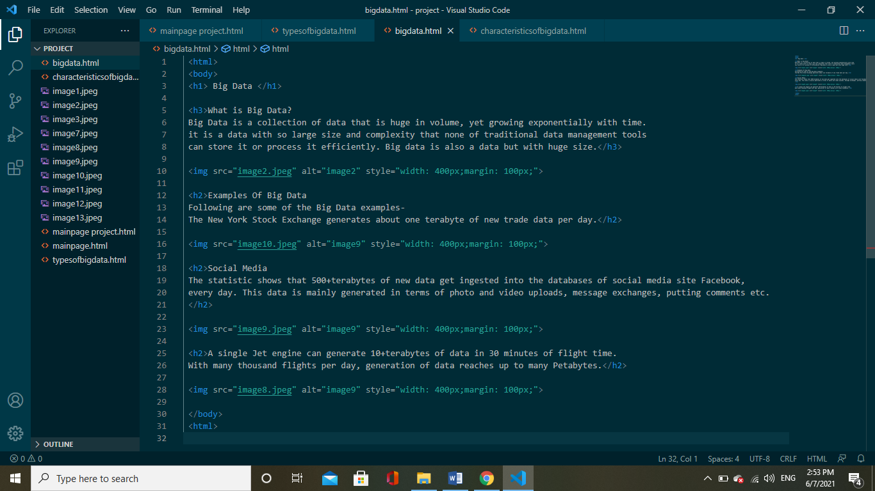

## types of big data



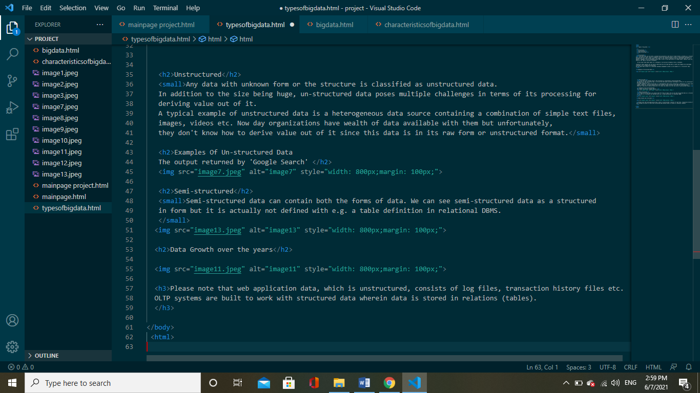

## Characteristics Of Big Data

